S3 Task

1. **Create an S3 bucket and upload some objects to S3.**

go to aws console

search S3 and click on it

click on create bucket

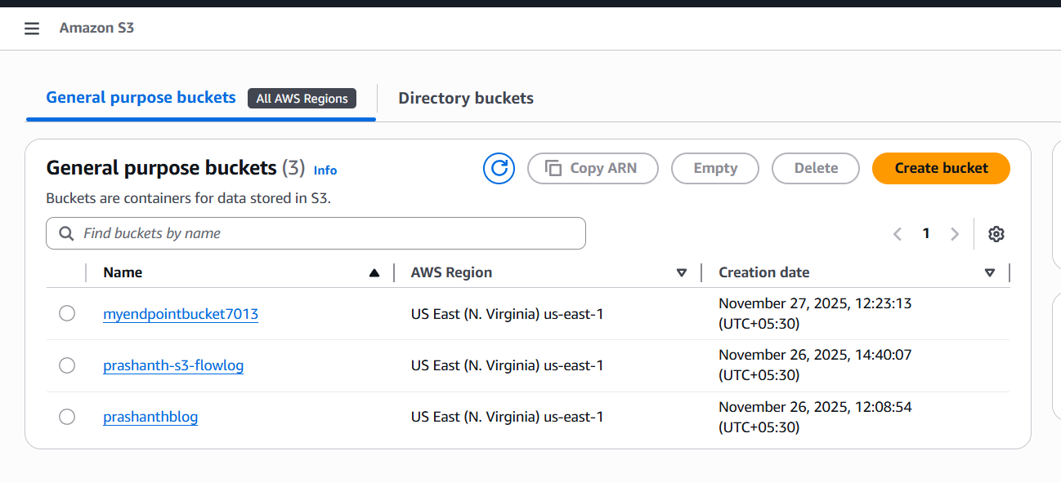

after clicking…enter the name which will be unique

untick the block public access settings

once you done it…click on create

the bucket has been created

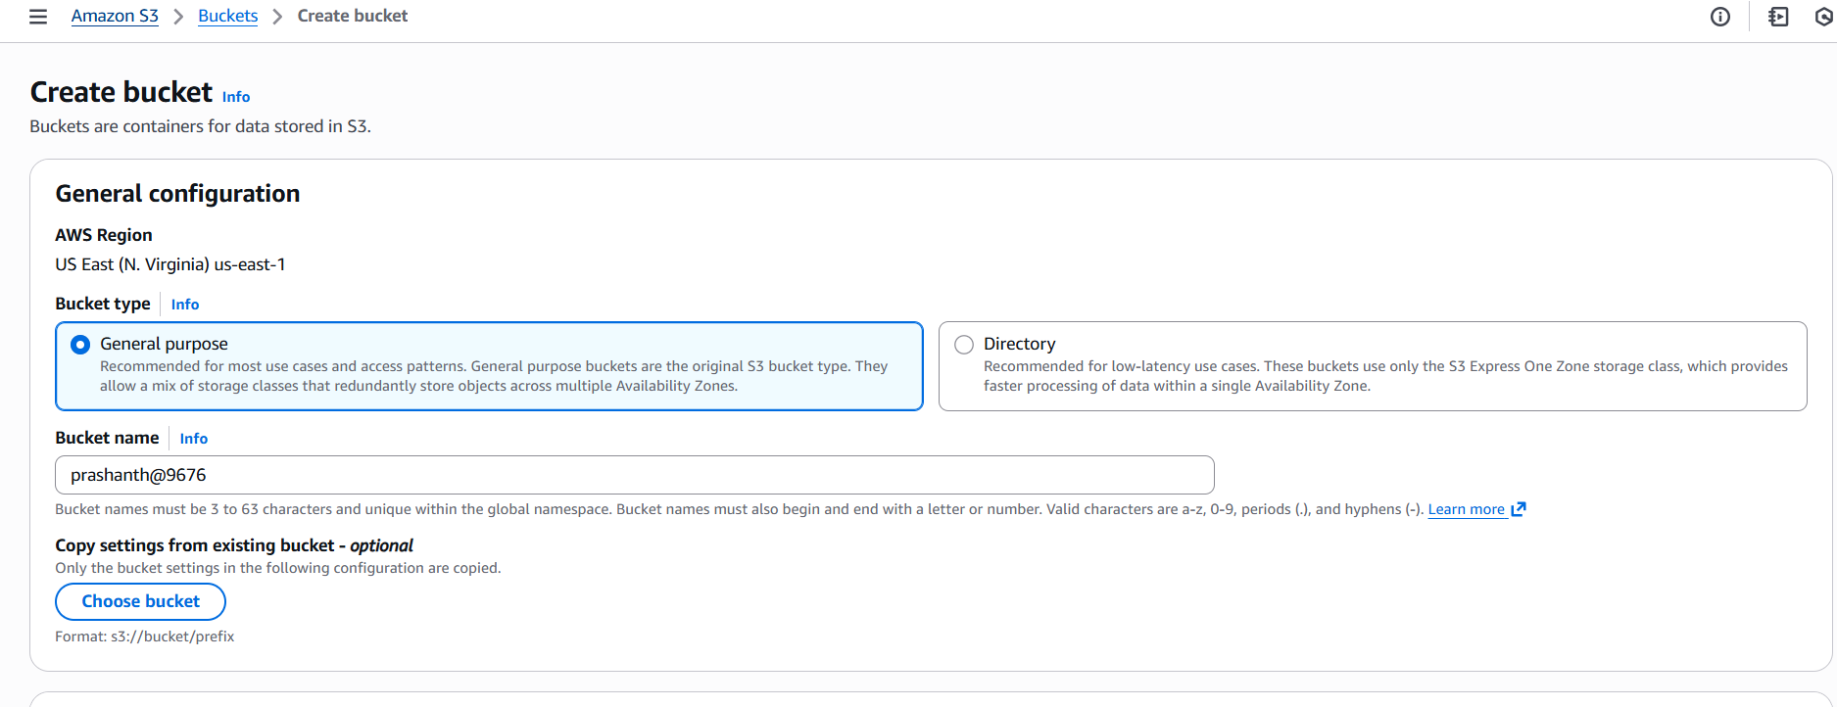

now click your created bucket name to upload the objects

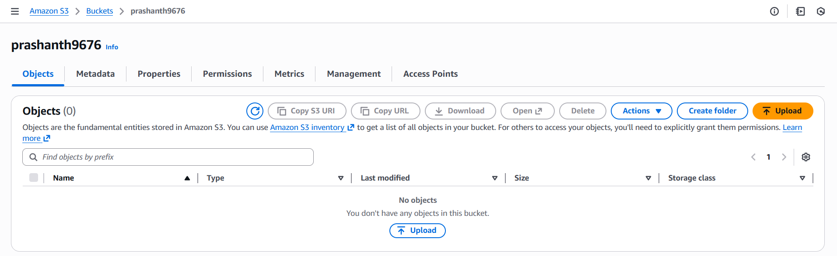

click on upload

you can upload any txt file or image file also

here I uploaded .txt file

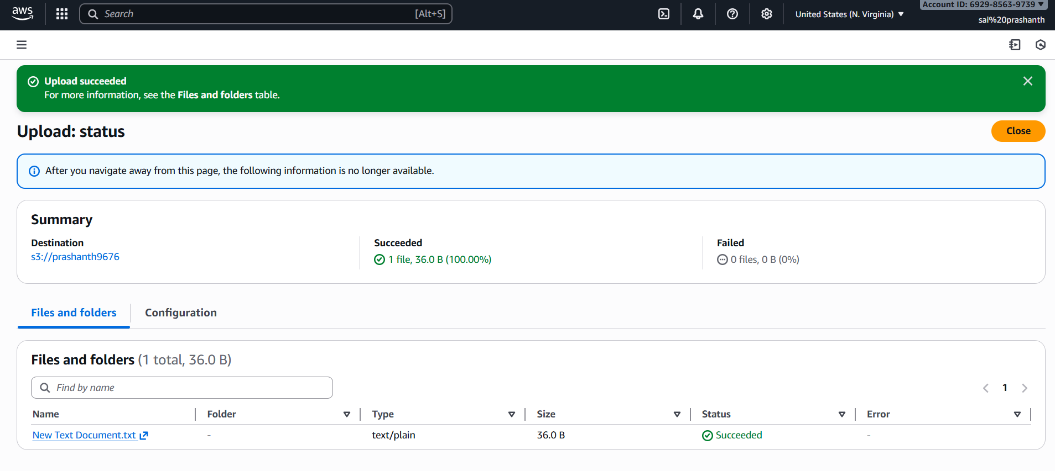

if not not getting success enable to the public access

click on object actions—click on make public using ACL

and again click on make public

once it has been copy the url link

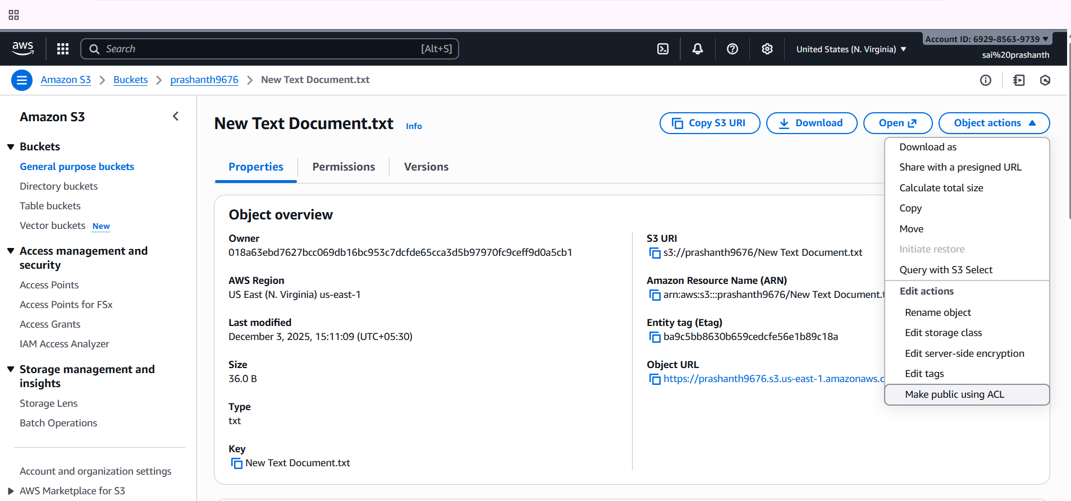

copy the link and paste in your browser and press enter

you can display what ever the text you have been in your object

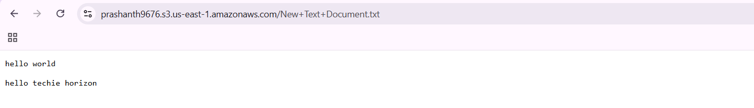

1. **Deploy a static website in the S3 bucket**

first download the any html link in <https://www.tooplate.com/free-templates>

after getting downloaded extract it

now in S3 Bucket—click on upload—upload the folder which you have been uploaded

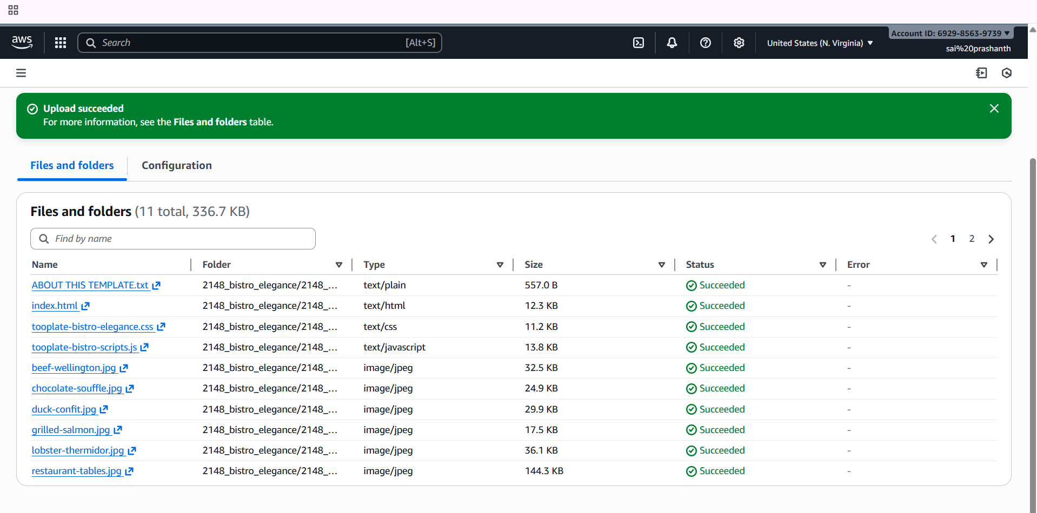

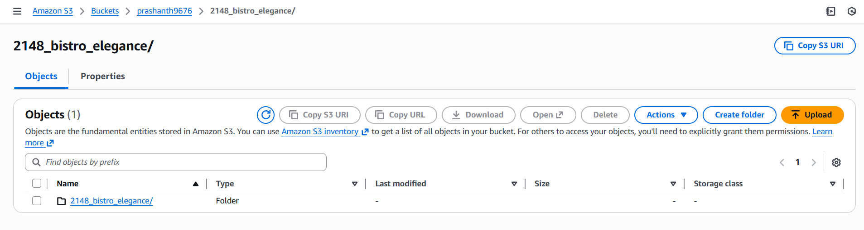

after uploading it

click on it

enable all the files tp public CL

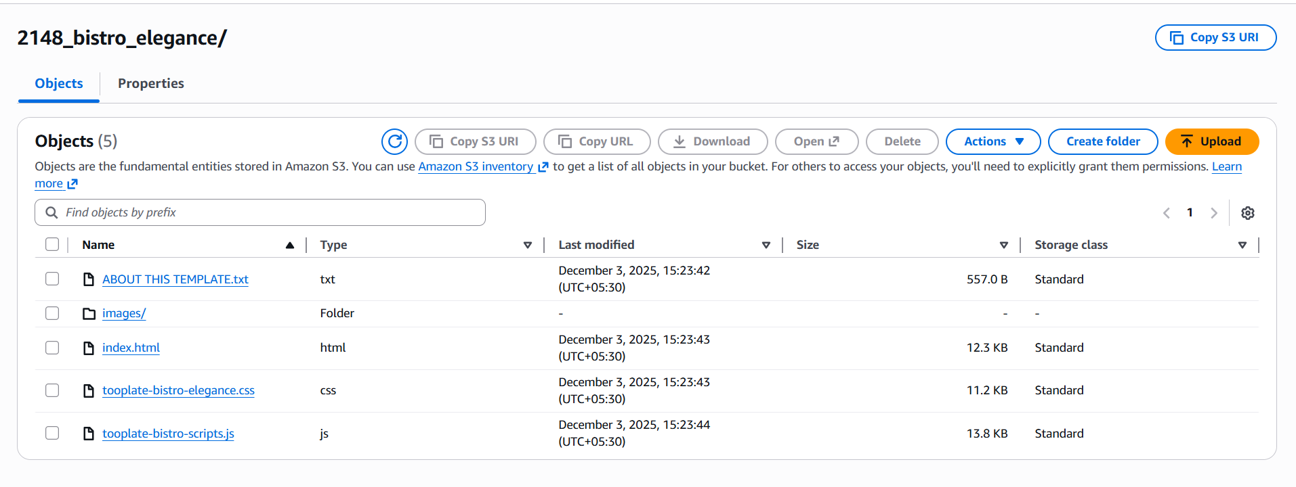

after enabling make public status

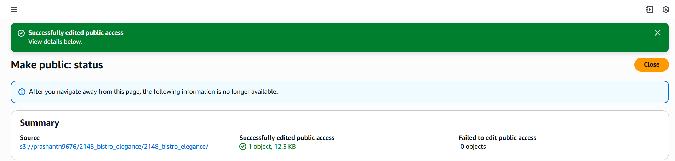

once it has been done

click on index.html

and copy the url

why we will copy from index means it is in html format

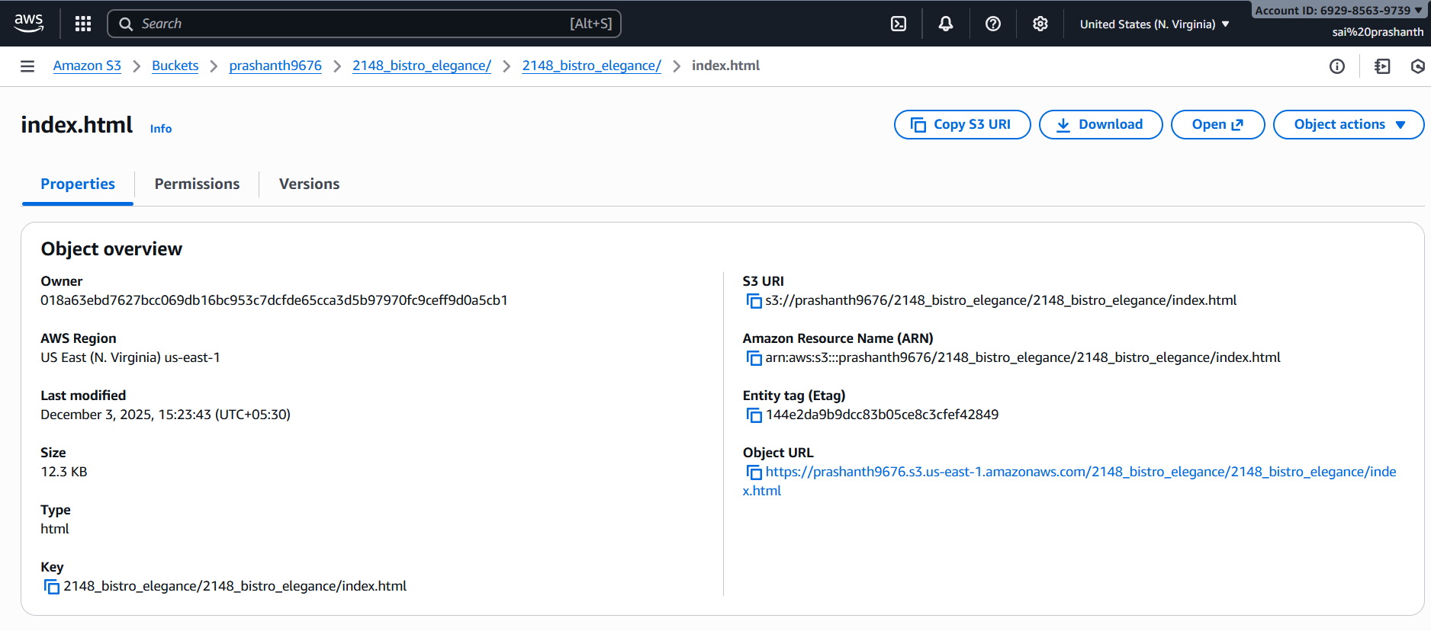

and paste it in your browser

you can see the display

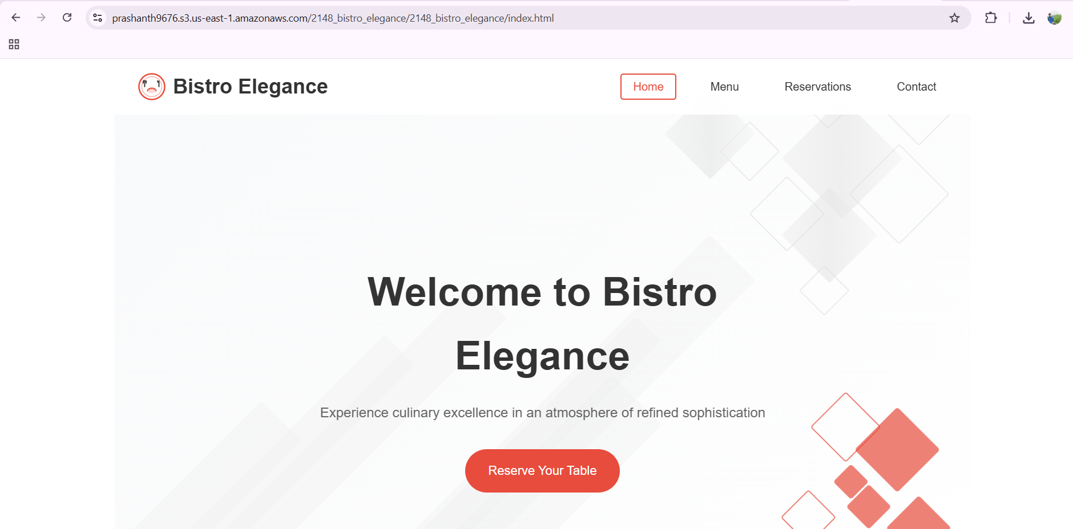

1. **Enable cross-region replication on S3 buckets.**

first create two buckets in two different regions as we are enabling cross -region



now open the bucket in your source first and click on properties

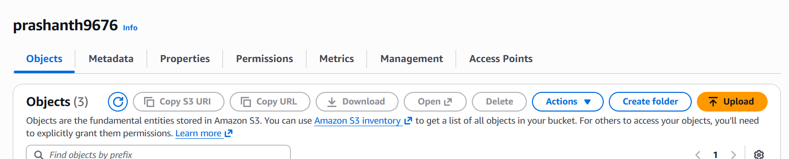

after clicking it, we need to enable the bucket versioning

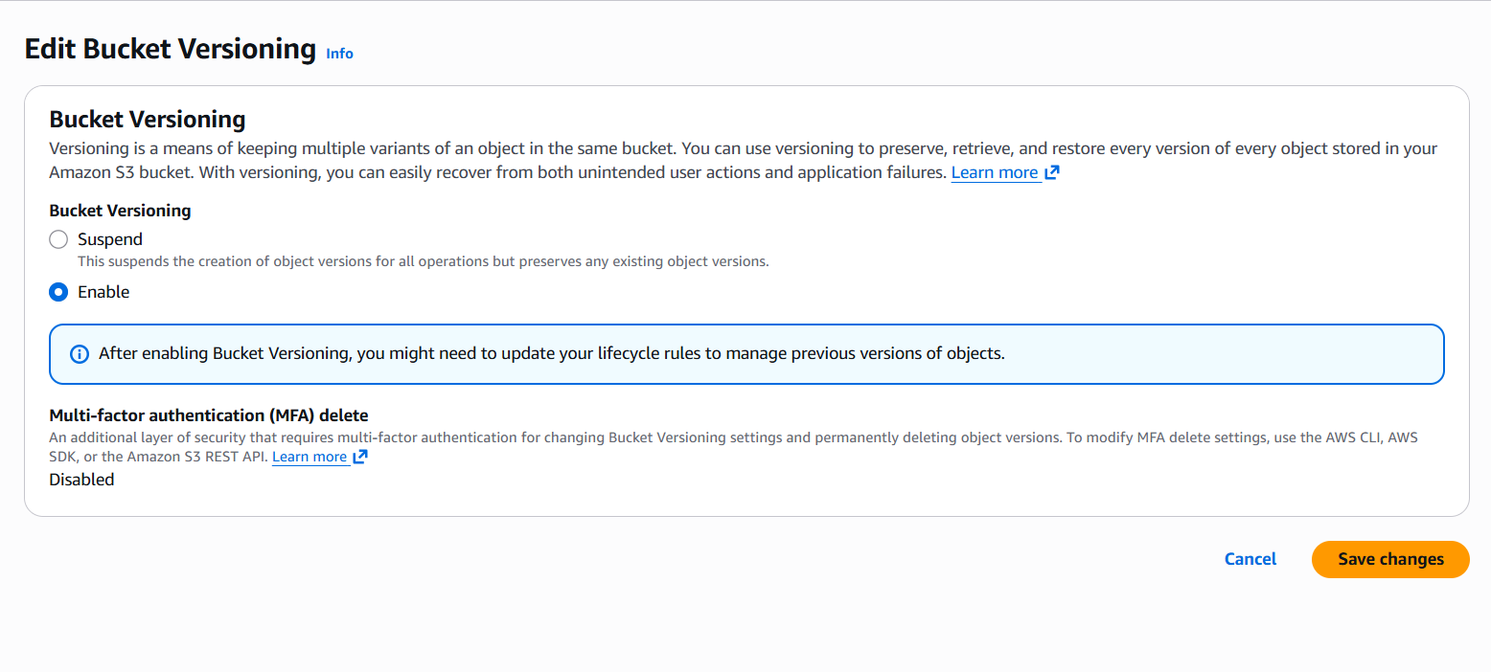

now do the same different region enable the bucket versioning

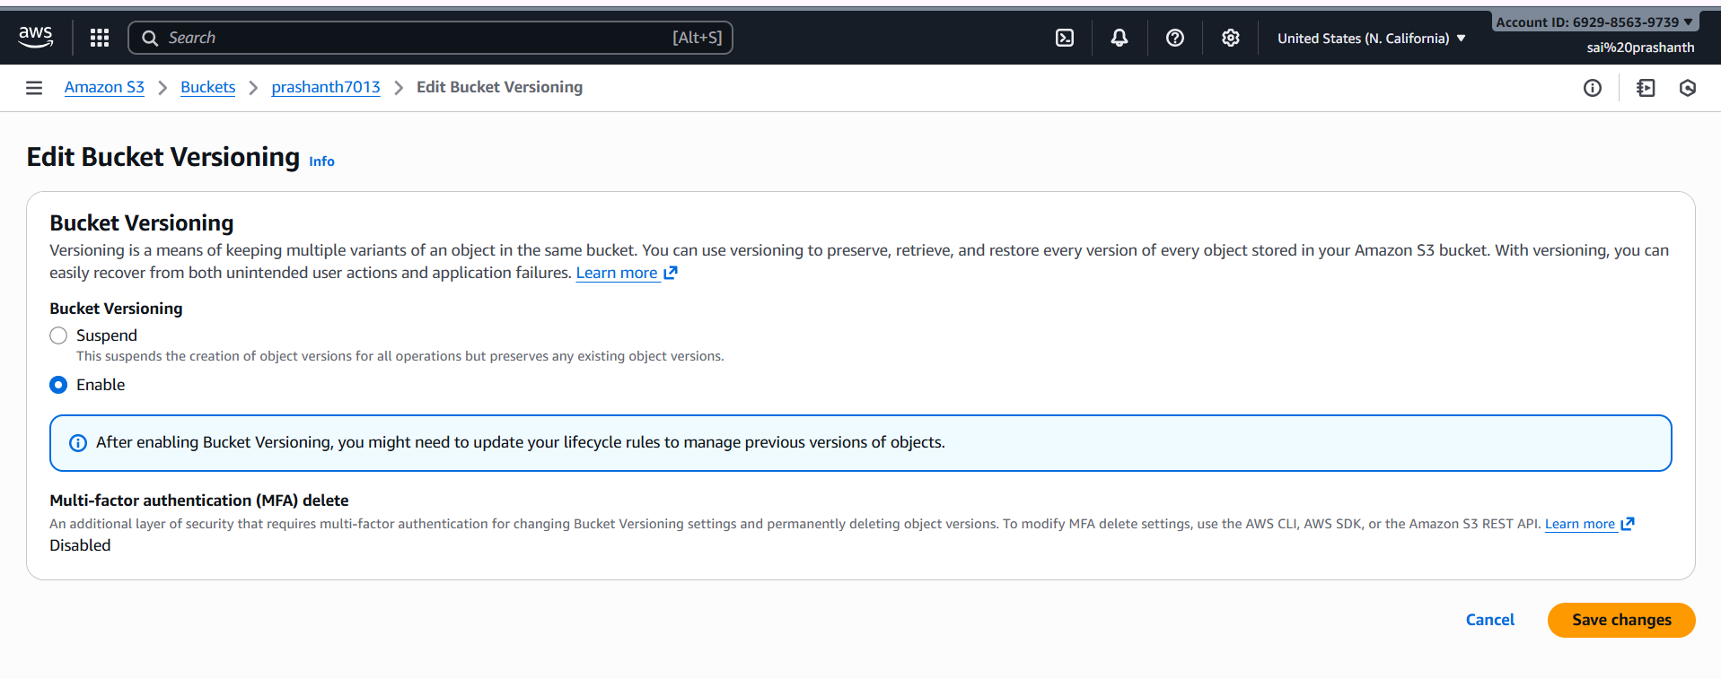

to enable the replication

source bucket—click on your bucket—click on management—click on create replication rule

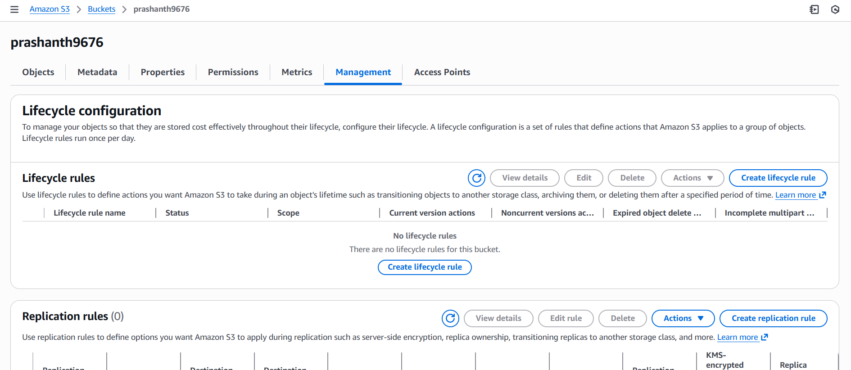

next enter replicon name and enable the status

in source bucket click on apply to all objects in the bucket

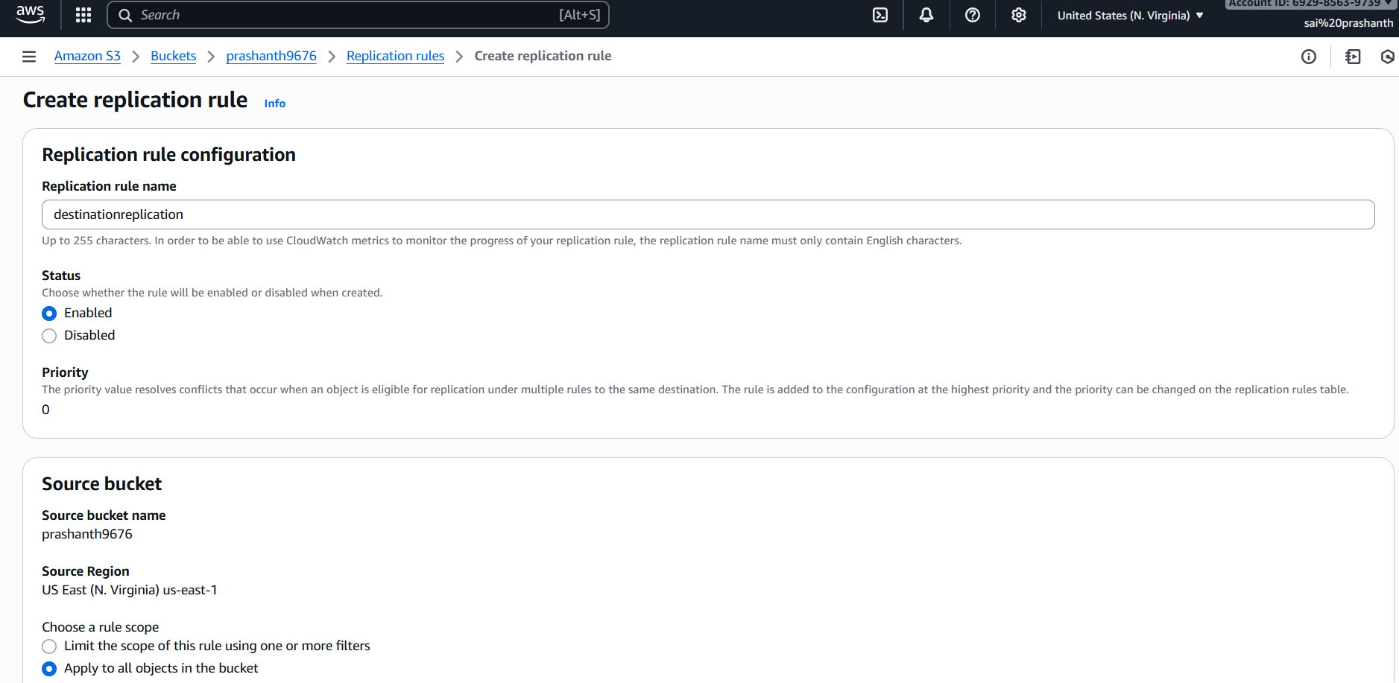

click on destination and enter the bucket name which you have created in another region and select new IAM role and click on save

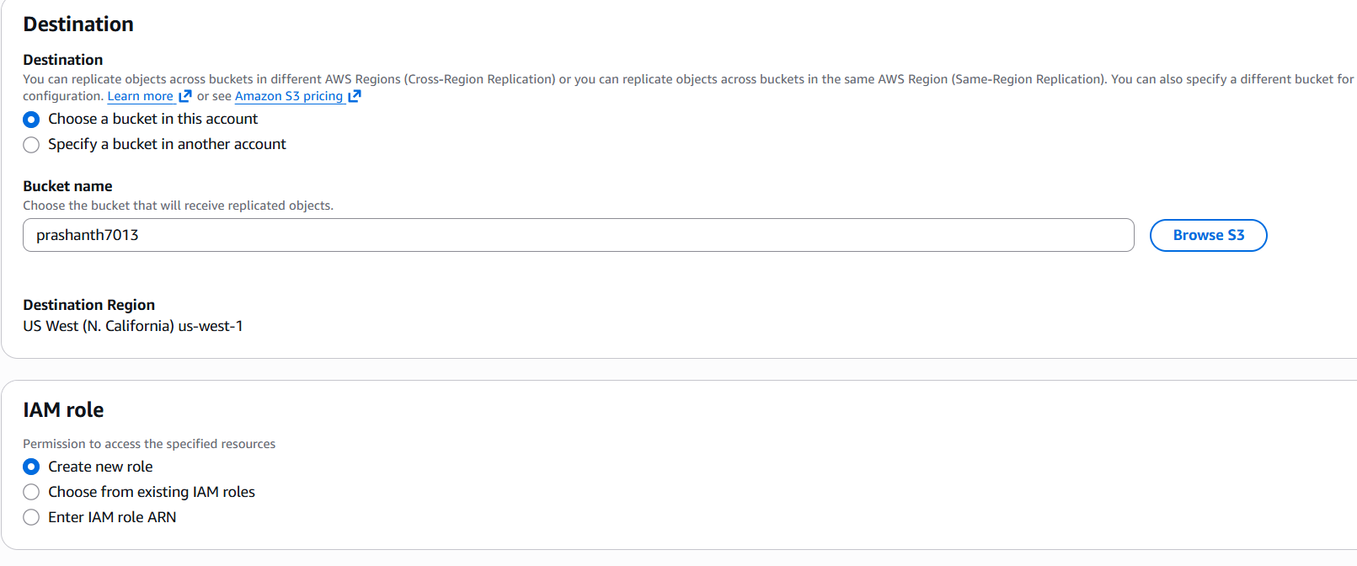

once you clicked save you can see the page create batch operations job

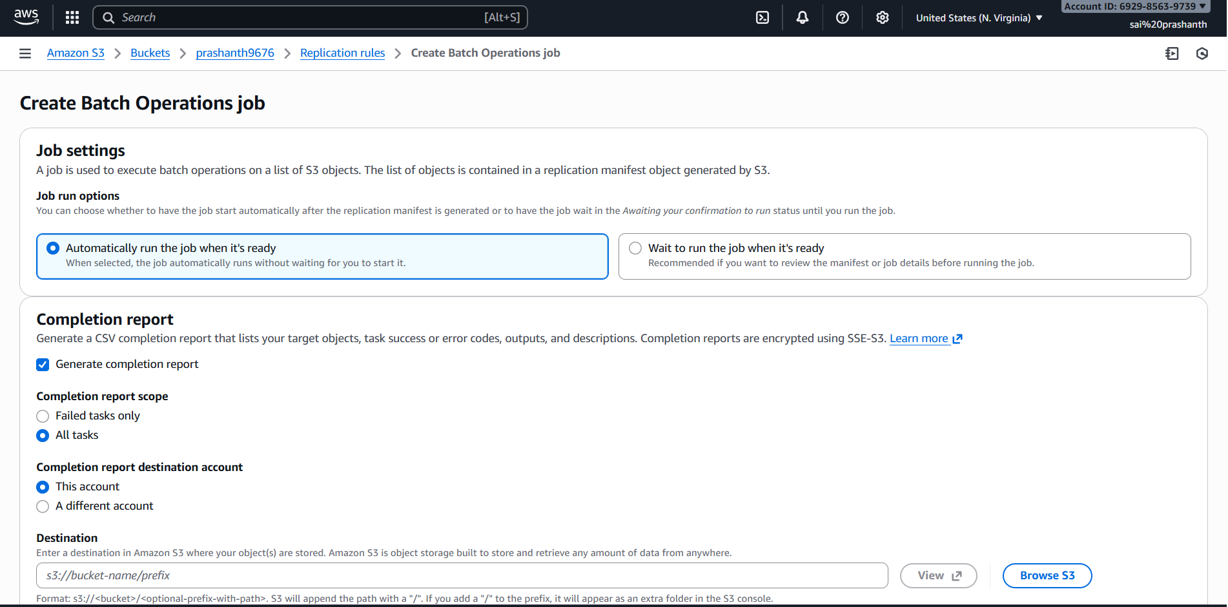

now in the destination select browse S3 from where you need to move the objects

once it has been save it

now you can see the objects has been moved on….

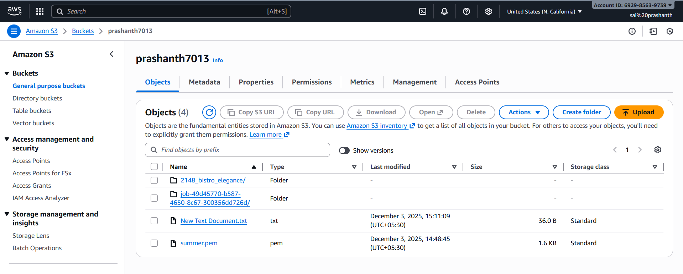

1. **Configure a bucket policy so only the admin user can see the objects of the S3 bucket.**

first create an IAM user with your custom password to give access to see the bucket list

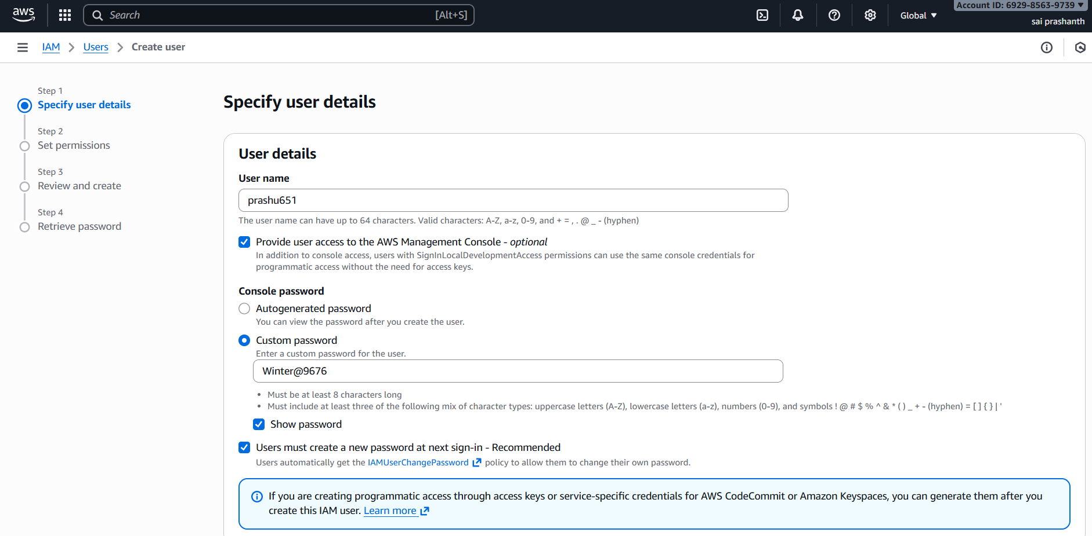

to enable the permission we ened to give s3 full access

after giving the permission

go to S3—select the bucket—in permissions—add the policy

add your username and account id and bucket name in the policy

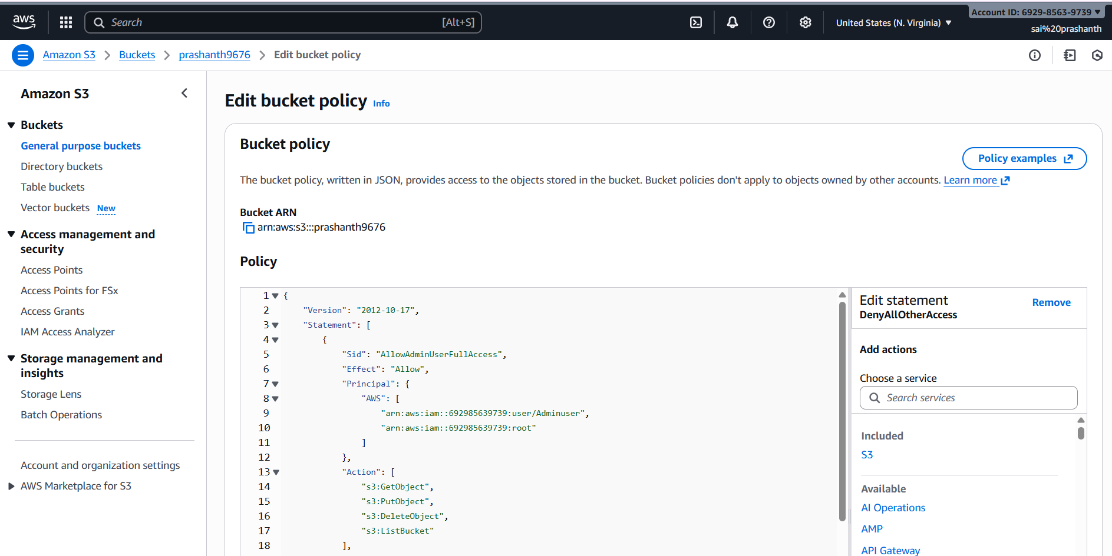

now save it

now you can sign out and login with IAM user

enter your credentials—account number—username and password

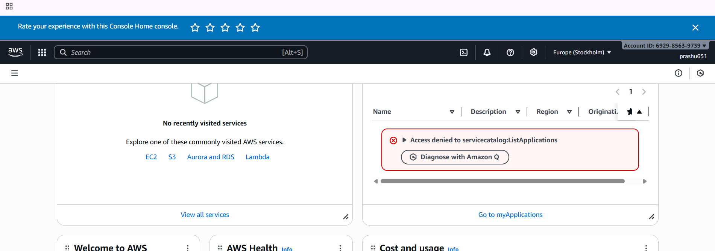

now click on S3 and view the bucket and bucket list

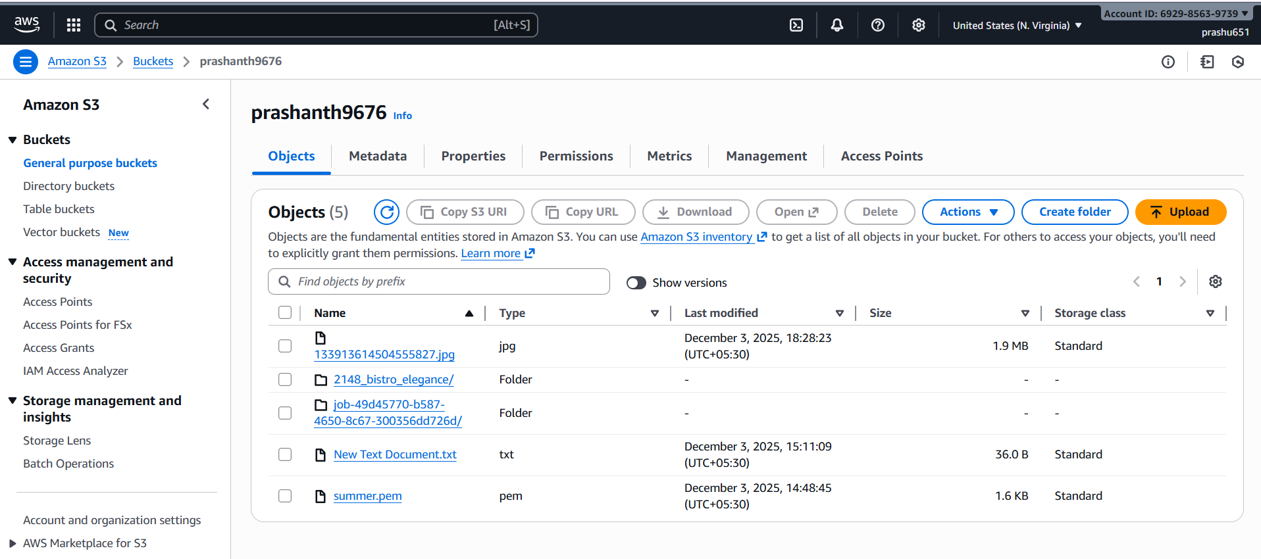

1. **Set up lifecycle policies to automatically transition or delete objects based on specific criteria.**

first go to S3

select your bucket—go to management—click on lifecycle configuration

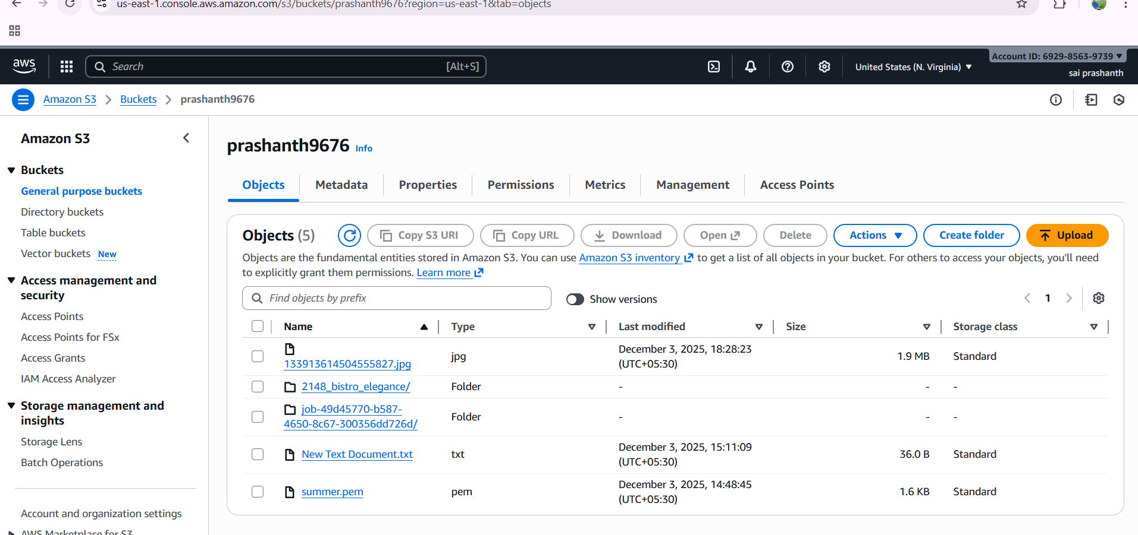

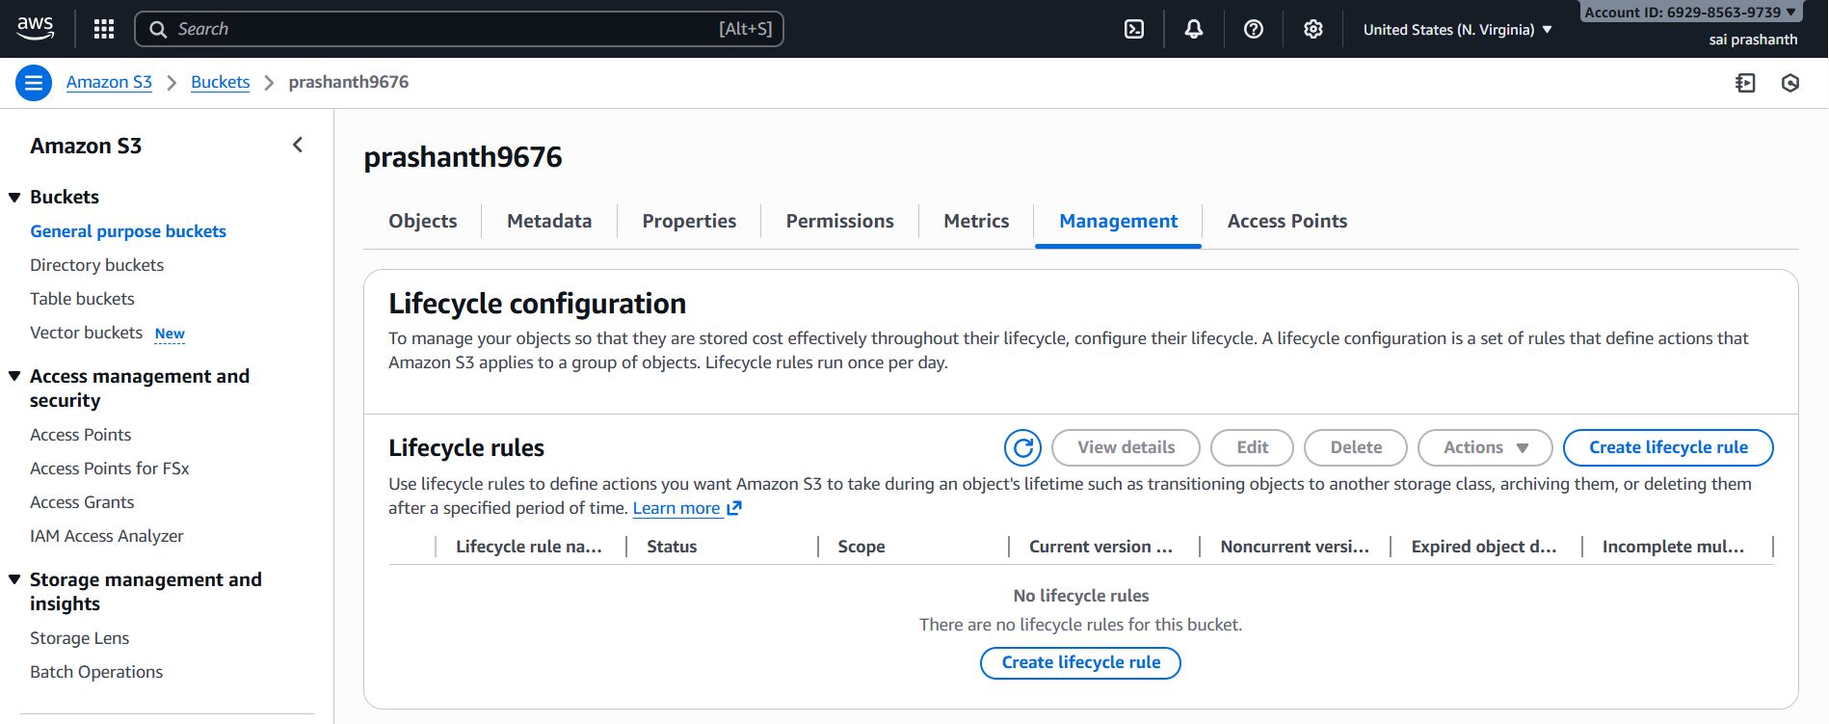

now click on create life cycle rule

now enter lifecycle name

click on apply all

select rule action transition current version

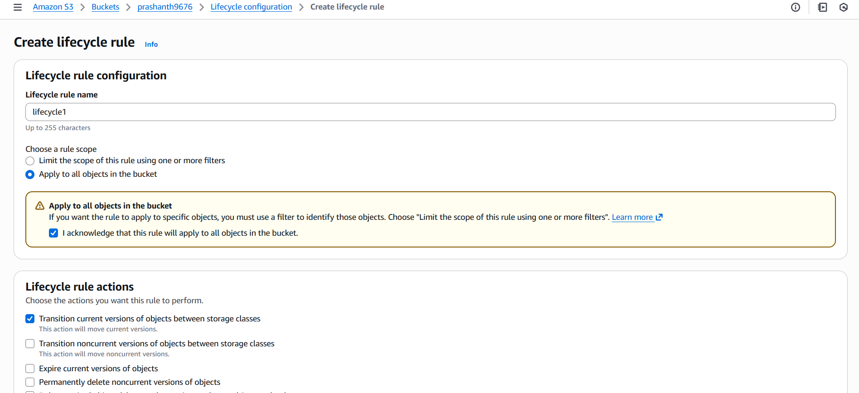

now add the transitions to move the objects between storage classes to view the objects and to reduce the cost

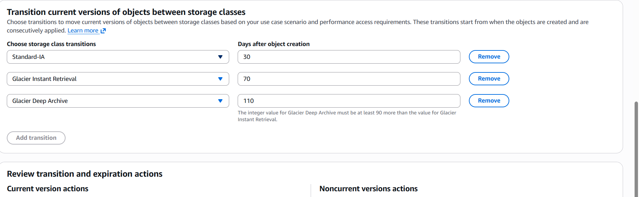

finally click on create rule

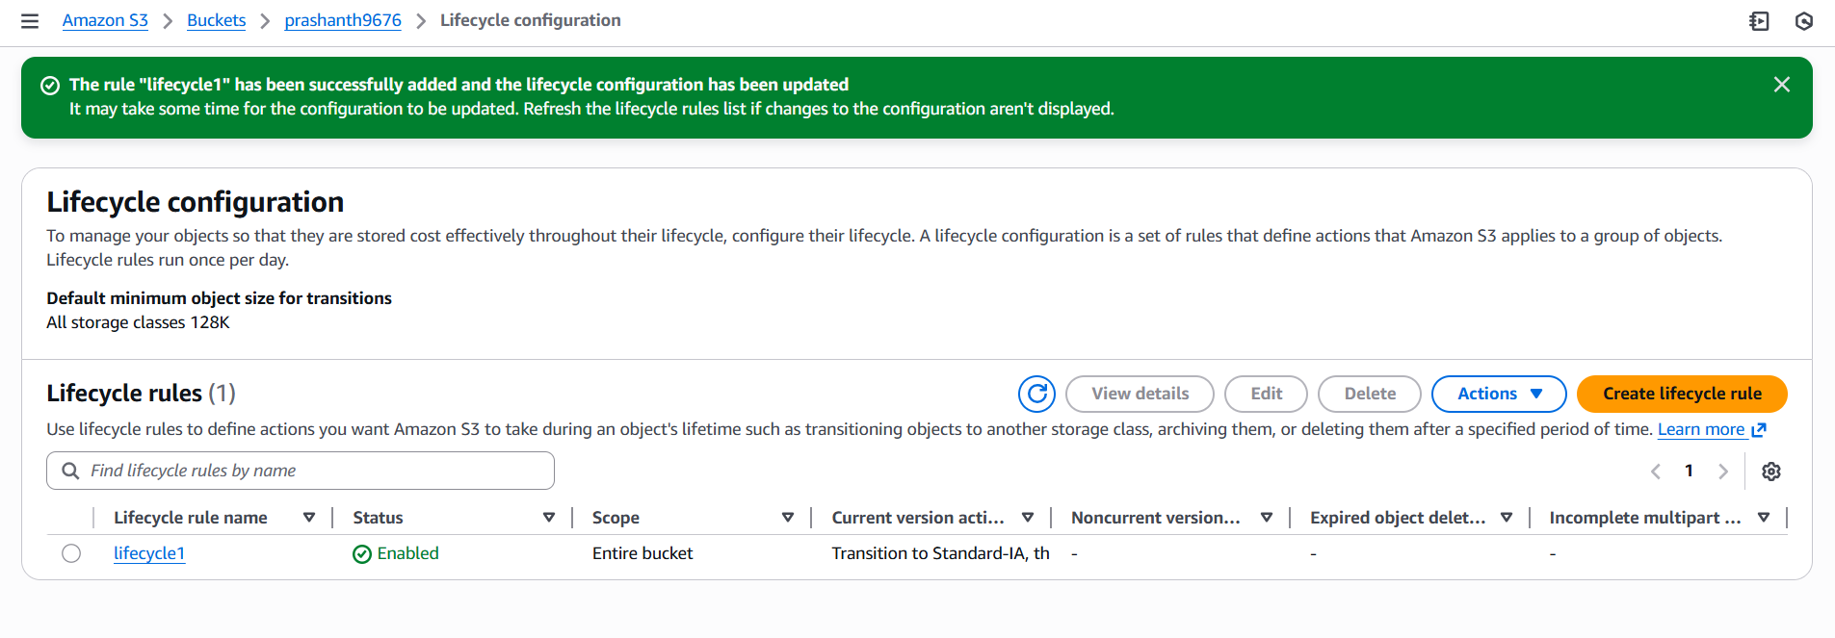

1. **Push some objects to S3 using the AWS CLI.**

go to security credentials

copy the access key and secret key to aws configure

connect to git bash—aws configure

enter access key and secret key and region and format

to view the list

aws s3 ls

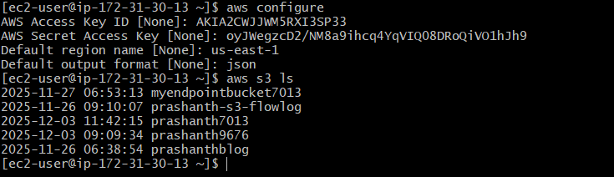

to view the particular objects in one bucket

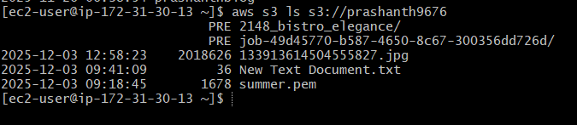

to move the file to bucket

I created through touch command file3.txt

to view aws s3 ls s3://prashanth9676

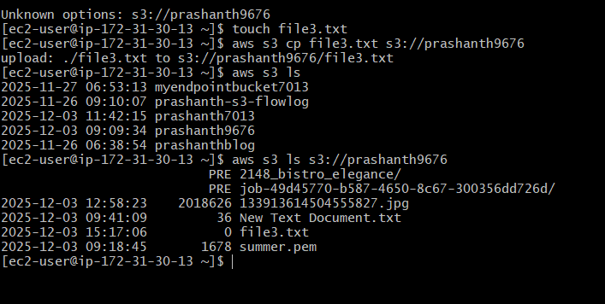

1. **Write a Bash script to create an S3 bucket.**

go to git bash

vi createbucket.sh

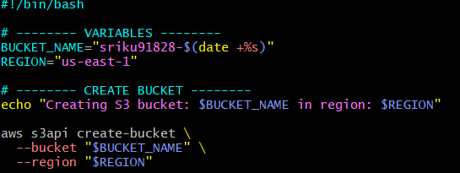

once you executed we need to give permission

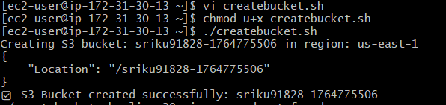

once it has been executed check the list of buckets

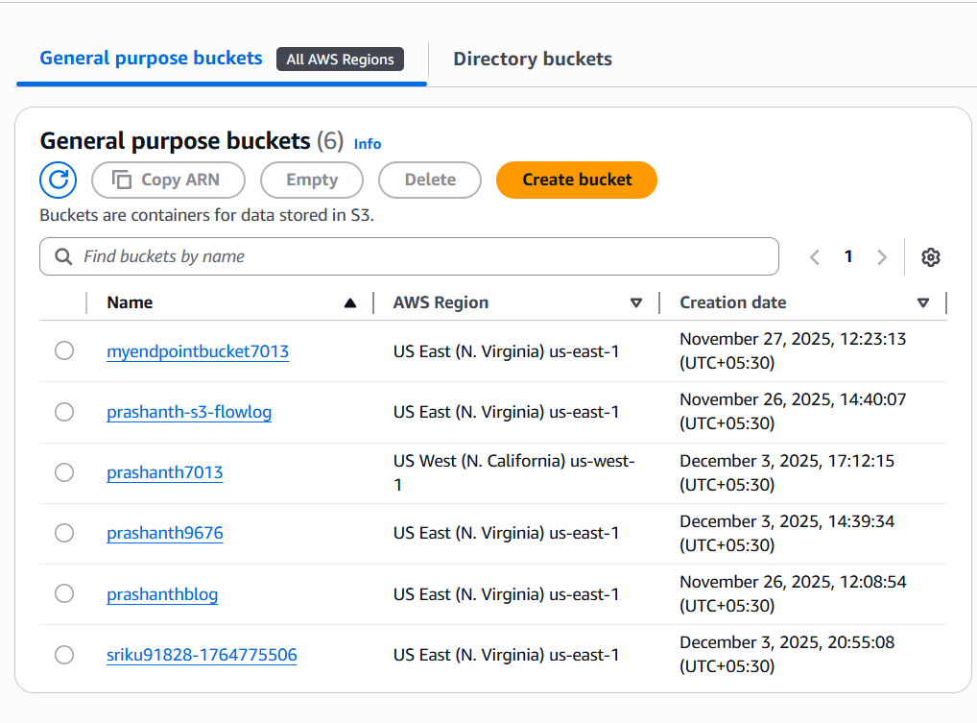

1. **Upload a 1 GB file to S3 using the CLI.**

I have uploaded 1gb by using the command ‘dd if=/dev/zero of=1gbfile.bin  
bs=1M count=1024’

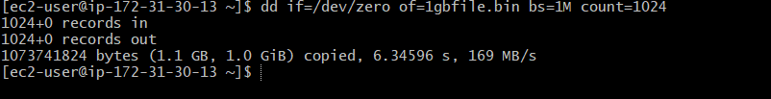

to upload to s3

we need to use aws s3 cp 1gbfile.bin se://prashanth9676

the file has been moved to s3 now….

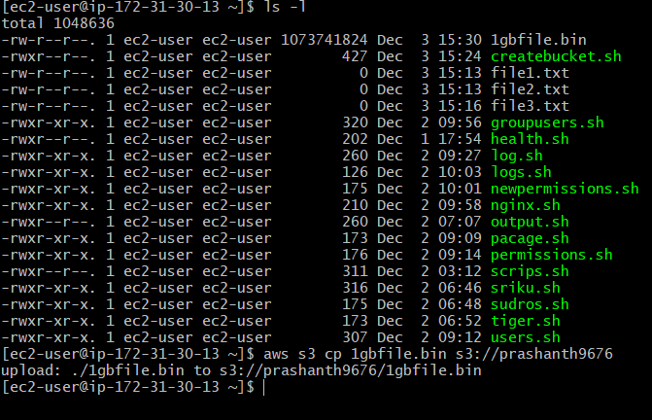

to view in s3

